**Predicting Customer Churn in a Telecom Company**

**1. Introduction**

The telecommunications dataset utilized in this analysis comprises various features related to customer behavior, demographics, and service usage. These features include customer account information, call details, internet usage, and subscription plans. The primary goal of this analysis is to predict customer churn, which refers to the phenomenon where customers discontinue their service subscription. Churn prediction is a critical task for telecommunications companies as it allows them to identify at-risk customers and take proactive measures to retain them, ultimately improving customer satisfaction and reducing revenue loss.

**2. Exploratory Analysis**

Exploratory data analysis (EDA) is a crucial step in understanding the dataset's characteristics and gaining insights into potential patterns or relationships. The EDA process involved in this analysis includes:

**Loading the Dataset:** The dataset is loaded using the pandas library, and the first few rows are inspected to understand its structure and the types of features available.

**Handling Missing Values**: Any missing values in the dataset are identified and handled appropriately. In this analysis, rows with missing values are dropped to ensure data integrity.

**Summary Statistics:** Summary statistics, such as mean, median, minimum, and maximum values, are computed for numerical features to gain an understanding of their distributions and central tendencies.

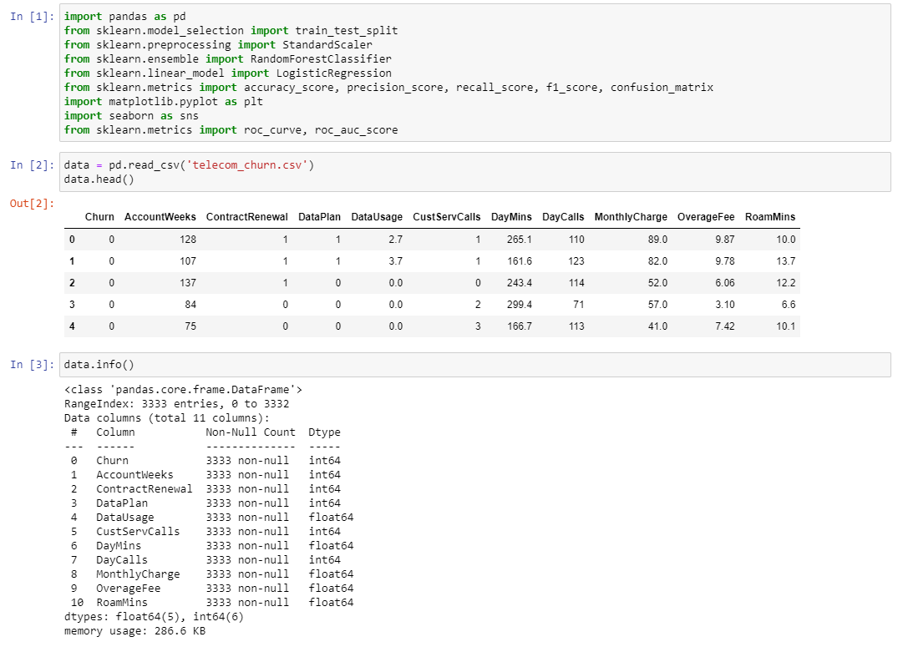

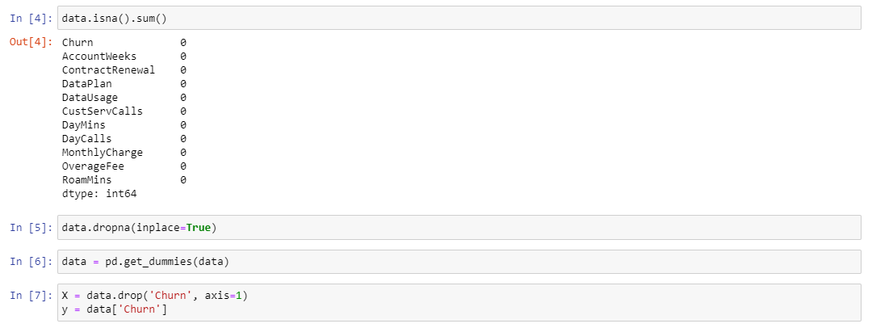

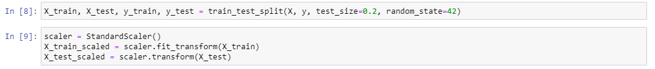

**Visualization**: Various plots, such as histograms, scatter plots, and correlation matrices, are generated to visualize the distributions of numerical features and explore relationships between variables. These visualizations aid in identifying potential patterns or trends in the data.

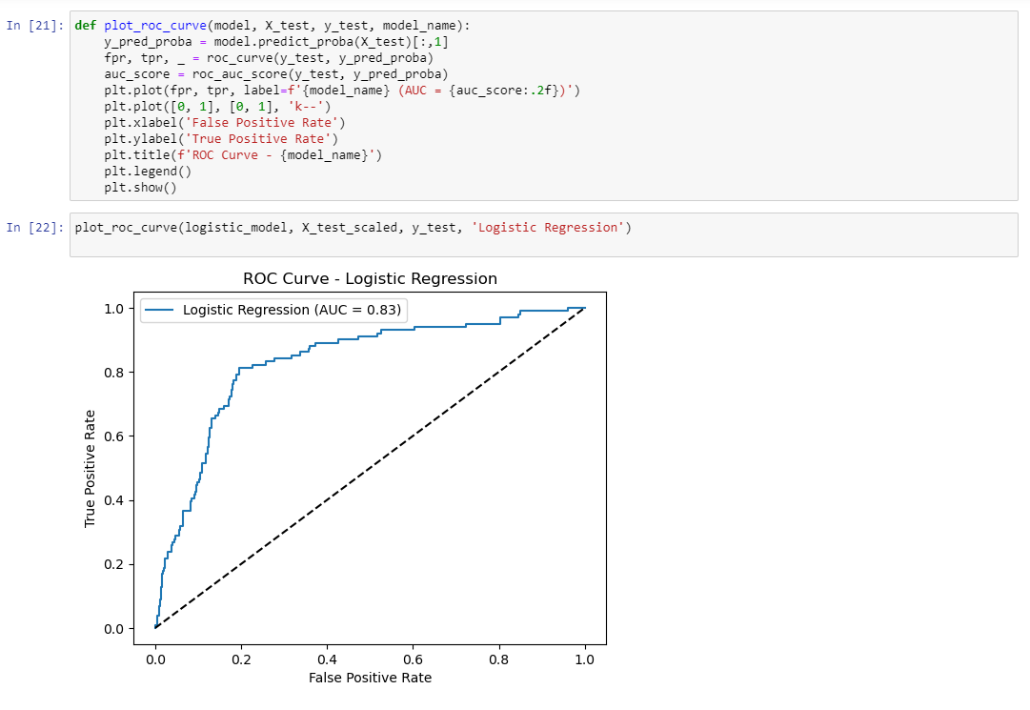

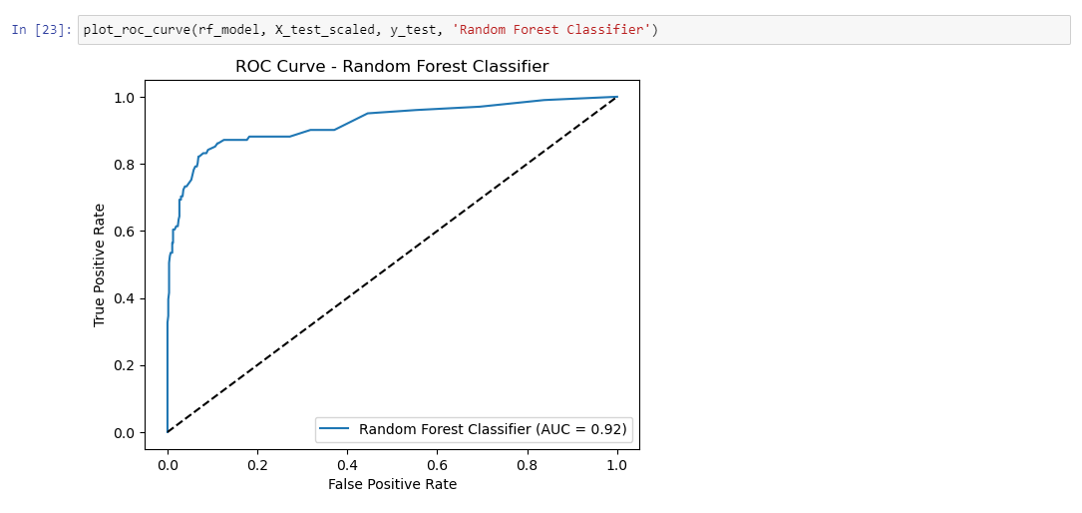

**3. Building Predictive Models**

Two predictive models are constructed in this analysis:

**Logistic Regression:** Logistic regression is a statistical model used for binary classification tasks, where the target variable has two possible outcomes (e.g., churn or non-churn). The logistic regression model is trained using the training data and used to predict the probability of churn for each customer.

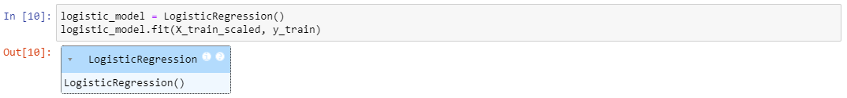

**Random Forest Classifier:** The random forest classifier is an ensemble learning method that combines multiple decision tree classifiers to make predictions. It is particularly effective for classification tasks and can handle both numerical and categorical features. The random forest classifier is trained using the training data to predict customer churn.

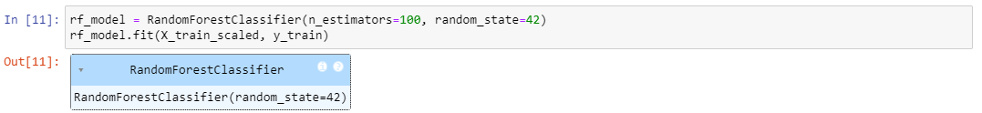

**4. Assessing Model Performance**

The performance of the predictive models is evaluated using various metrics:

**Accuracy:** The proportion of correctly classified instances, calculated as the ratio of correctly predicted observations to the total number of observations.

**Precision:** The proportion of true positive predictions out of all positive predictions made by the model. It measures the model's ability to avoid false positive predictions.

**Recall:** The proportion of true positive predictions out of all actual positive instances in the dataset. It measures the model's ability to identify all positive instances.

**F1 Score:** The harmonic mean of precision and recall, providing a balance between the two metrics and accounting for imbalanced datasets.

**Confusion Matrix:** A table that summarizes the counts of true positive, true negative, false positive, and false negative predictions made by the model.

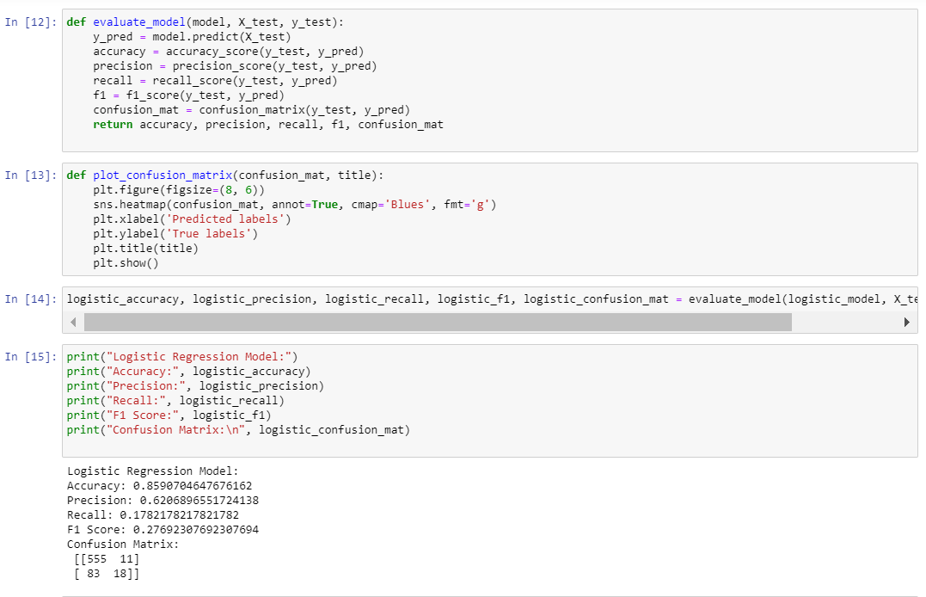

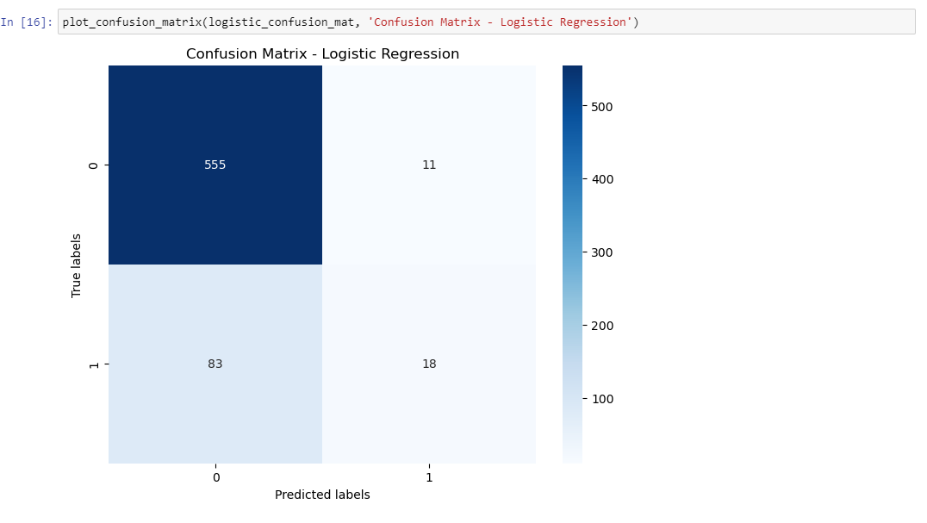

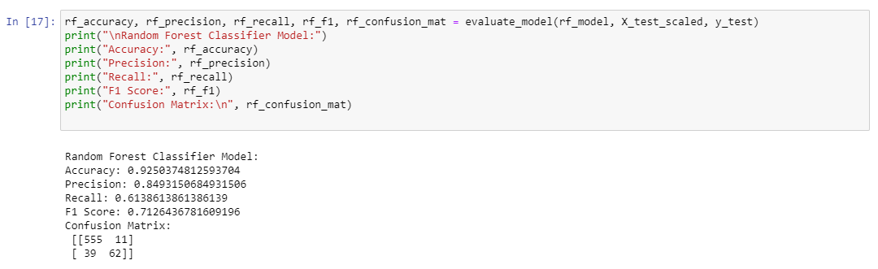

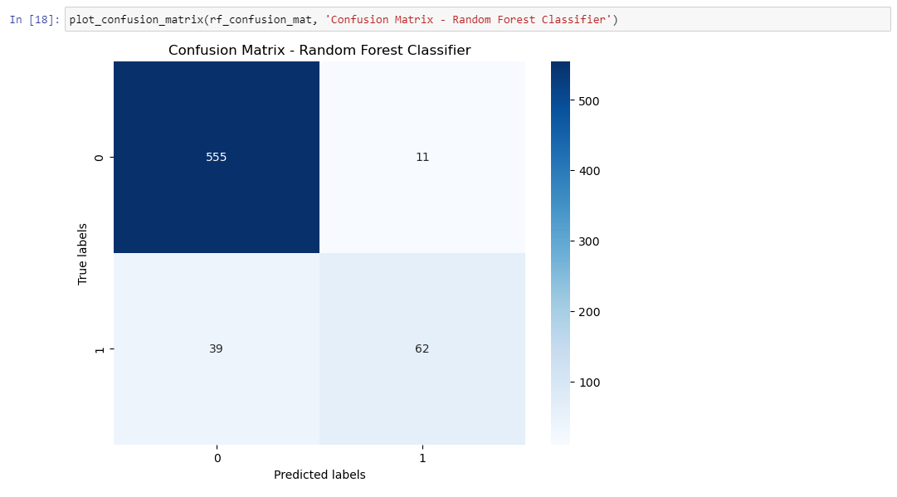

**5. Reporting Results**

The results of the model performance evaluation, including accuracy, precision, recall, F1 score, and confusion matrices, are reported for both the logistic regression and random forest classifier models. These metrics provide insights into the effectiveness of each model in predicting customer churn.

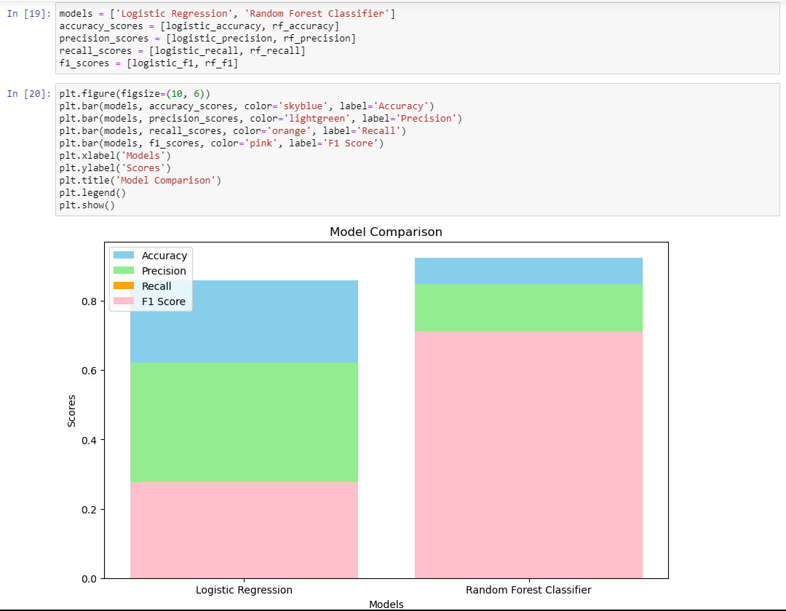

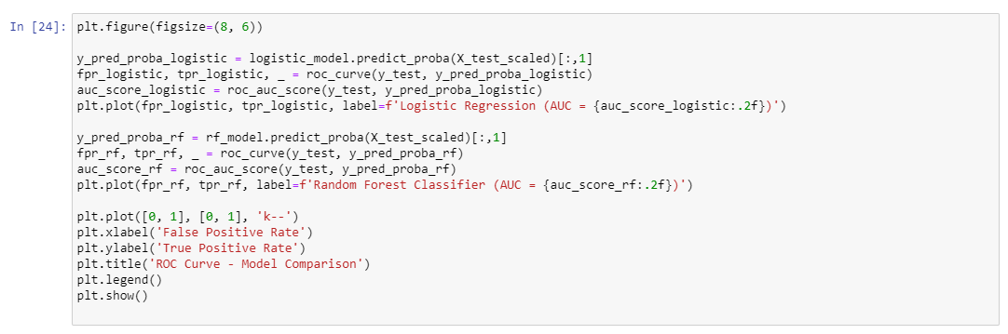

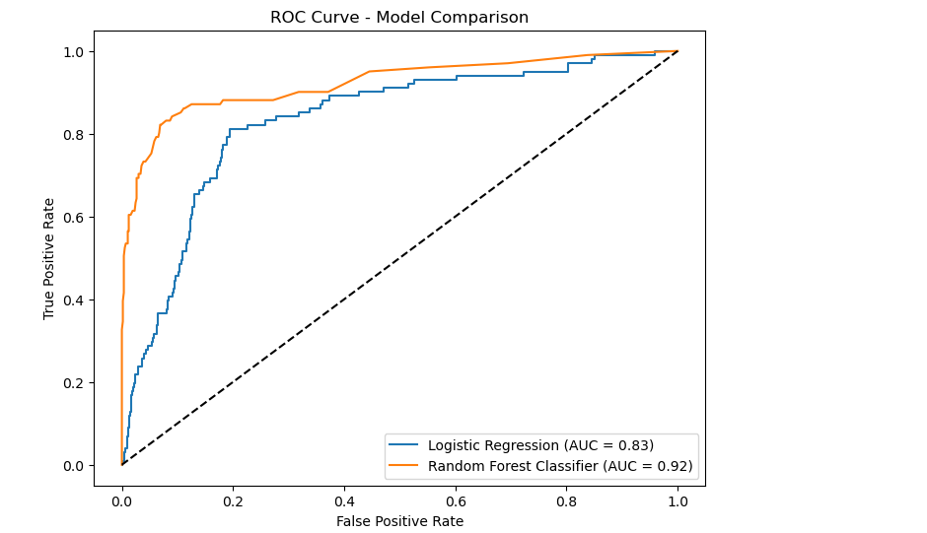

**Future Importance:**

For the Random Forest Classifier, feature importance is computed to identify which customer features have the most significant impact on predicting churn. This information can guide business decisions by highlighting factors that contribute most to customer attrition.

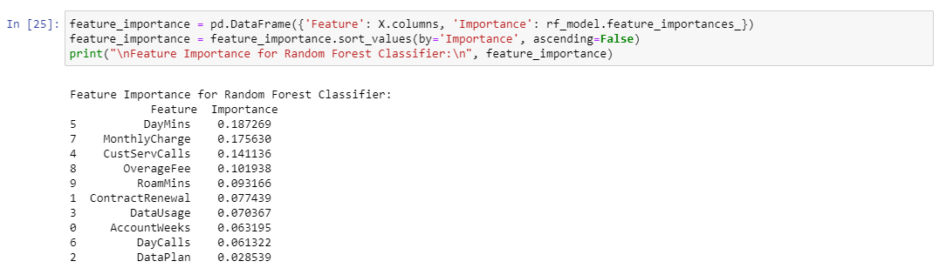

**6. Future Work**

Potential future directions for the analysis are outlined, including:

- Further optimization of model parameters to enhance performance.

- Exploration of alternative machine learning algorithms to compare predictive capabilities.

- Conducting deeper feature engineering to uncover additional insights and improve model interpretability.

**7. Conclusions**

In conclusion, the analysis highlights the importance of churn prediction for telecommunications companies and the effectiveness of logistic regression and random forest classifier models in addressing this task. Insights gained from the exploratory analysis and model performance evaluation can be used to inform strategic decisions aimed at improving customer retention and reducing churn rates. Recommendations for the telecommunications company may include targeted marketing campaigns, personalized retention offers, or service enhancements based on the predictive model's insights.

By following this detailed documentation outline, stakeholders can gain a comprehensive understanding of the analysis process, findings, and recommendations for future decision-making purposes.